Data modeling

Sumarry (project)
Project Summary – Data Modeling.
- Imported all datasets (Sales, Customer, Product, Region, Date, Returns) into Power BI

- Performed data cleaning in Power Query by removing null values, blank rows, and duplicates

- Fixed data types for all columns (IDs, Date, Revenue, Quantity, etc.)

- Created a Star Schema with Sales_Fact as the central table.

- Connected Customer, Product, Region, and Date tables using proper relationships

- Used many-to-one cardinality and single-direction filtering for all relationships

- Added Returns_Fact as a separate fact table instead of merging it with Sales

- Connected Returns to Sales using SalesID to track returned transactions

- Created an inactive relationship between Returns and Date to avoid ambiguity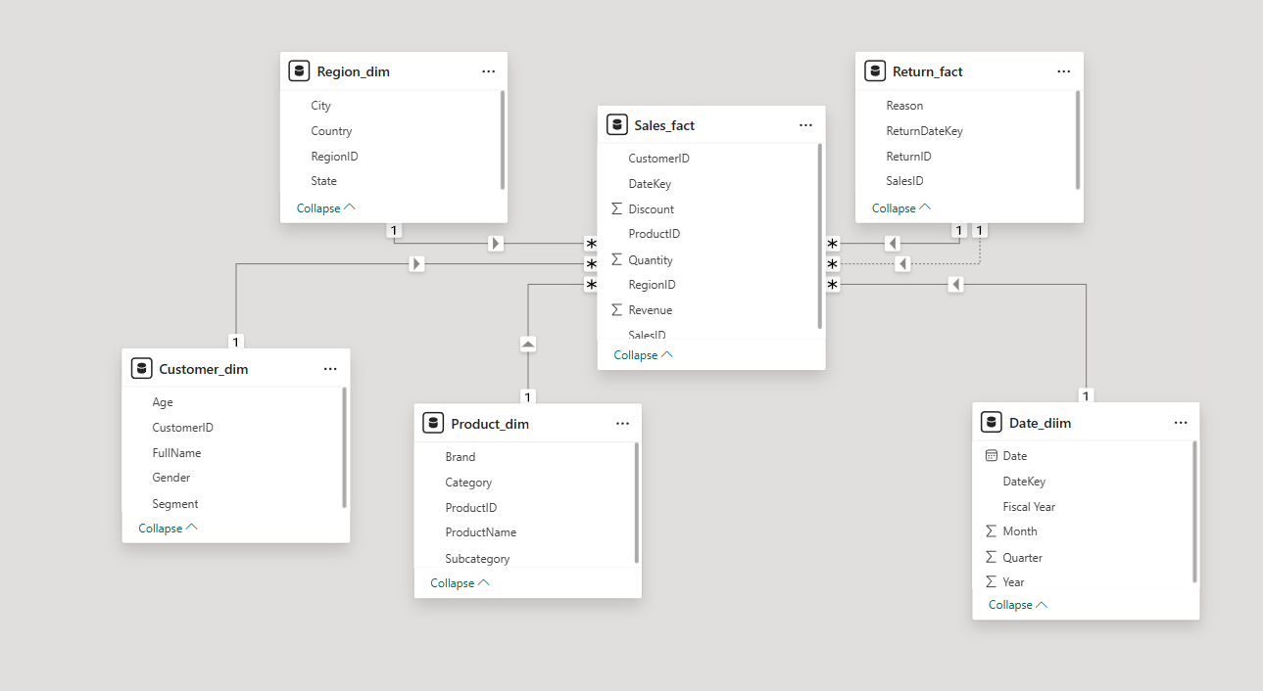

- Built hierarchies for Date, Region, and Product for better data analysi.

- Set correct data formats and data categories (Country, City, etc.)

- Verified the model using Matrix visuals to ensure correct data flow and relationships
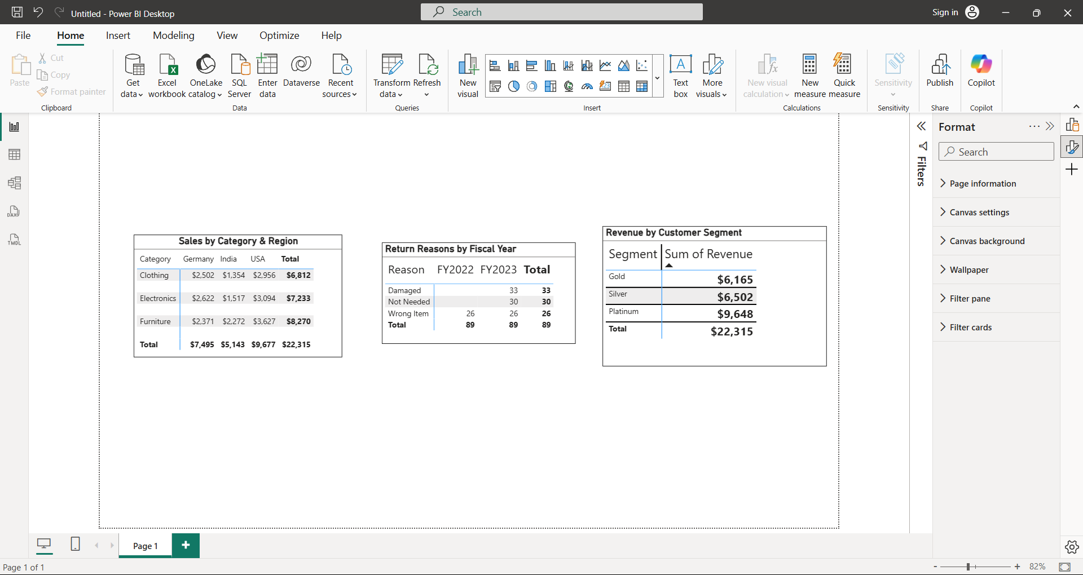

This project helped me understand complete data modeling process from data import and cleaning to building a structured and optimized model in Power BI.

